Faculty Council Newsletter
December 2016

President’s Report:

I am, as I am sure you all are, looking forward to a much-needed winter break! Whether it’s a vacation or a stay-cation, I do hope we all have a chance to rest and unwind from our busy lives.

I’d like to thank our very engaged Faculty Council members for their insight and suggestions at our meetings. These include Steve Ebert, Cristina Fernandez-Valle, Bill Self, Herve Roy, Jihe Zhao, Shazia Beg, David Harris, Laurel Gorman, Steve Lambert, and Cari Hernandez. I have been so impressed with their commitment to addressing the needs of all our faculty. Thanks also to Suzanne Stalvey, who’s attention to detail and organizational skill has truly increased productivity of the FC.

News:
1-The Office of Faculty Excellence released the results of the COACHE survey (done in 2015) and proposed implementation strategies to address the five priority areas for improvement identified from the survey. They include:
- Nature of work, including research, service and teaching loads
- Personal and family policies
- Recognition and appreciation
- Departmental leadership, quality and collegiality
- Promotion policies
https://facultyexcellence.ucf.edu/files/2016/09/COACHE-Proposed-Implementation-Strategies_2016.pdf

2-Here at the COM Faculty Council we are trying to improve the process of the faculty recognition and awards. Awards such as Faculty Excellence/RIA/and SOTL have criteria set by the Faculty Excellence office. These have financial awards associated with them, and provide in some cases an avenue to receive merit-based raises. Dr. German let us know recently that where other state universities eliminated these awards when the funding from the state was pulled, UCF remained committed to maintaining these awards and covers them from the University budget. In an effort to improve the awards process for COM awards (given in the fall), we are going to form a new “Awards Committee” of elected by department members to serve 2 years, ideally with an overlap of membership. It is hoped the committee will take a look at the existing recognition and increase numbers of opportunities, especially for junior and non-salaried core faculty and residents, to receive recognition for their contributions. Please let your chairs or faculty council representatives know if you are interested.

Thanks to Angie Griffin from Faculty Development for assembling the following chart of awards from the main UCF Faculty Excellence office:
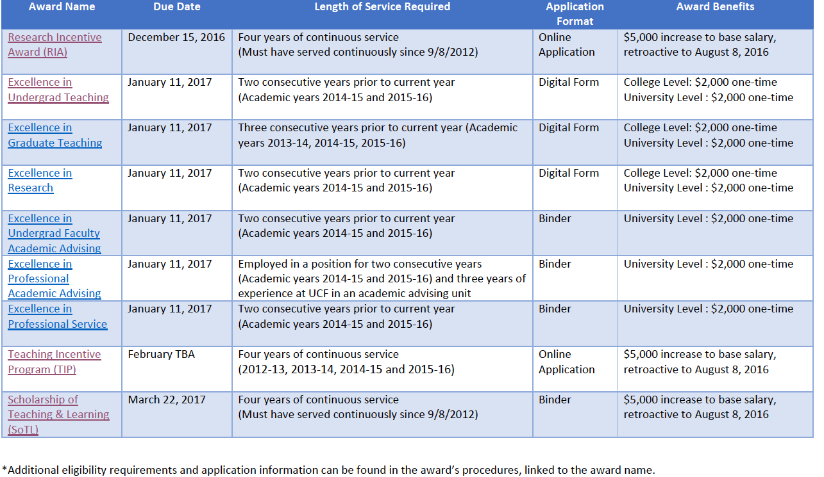

Many of the above awards require tenure and are only for UCF salaried faculty. We are hoping this can change one day.

Faculty Senate Updates from Bill Self:
1.) The faculty senate passed ten resolutions at the October meeting that were substantial changes to strengthen faculty governance at the University through the Senate by-laws. (http://facultysenate.ucf.edu/resolutions/2016_2017/index.asp)

2.) Nine of these resolutions have been signed by the Provost for approval.

3.) One of these resolutions has a substantial revision by the Provost (resolution 2016-2017-10); Essentially it alters the language such that a two thirds majority vote by the Senate can only serve to override the Provost, but that any decision by the President is final, and no override vote to appeal to the Board of Trustees will be included in the language.

4.) One resolution has not yet been acted on by the Provost. This resolution outlines the details of faculty governance within academic units (2016-2017-9).

In the past two Senate meetings there have been presentations by the Dean of the College of Medicine on the pending approval and plan for the teaching hospital (October meeting), and a presentation by the Vice Provost for UCF Downtown campus on the plans for this new campus (Thad Seymour, Jr., November meeting).

There is an abundance of information that is available on meeting agendas, minutes, resolutions at the faculty senate website (http://facultysenate.ucf.edu/index.asp)

Board of Trustees Dec 1 Meeting

One of the main topics that might be noticed from the Board of Trustees meeting is the following:

- CL-1 2016-19 Performance Incentive Measures and Goals─A motion was made and unanimously passed by the board approving the 2016-19 Performance Incentive Measures and Goals for the president and senior officers.
- CL-2 2016-19 Performance Unit Plan Awards─A motion was made and unanimously passed by the board approving the 2016-19 Performance Unit Plan Awards.

A robust discussion at the Faculty Council meeting resulted from review of the above measures, and initially some faculty expressed that this might represent “bonuses” for leadership that other faculty are not eligible to receive. In reality, across the board, as in other systems where incentive pay is used on top of salary, the base pay is low for the individuals involved, and the incentive pay, if earned by performance, plus the base pay would approach an average salary. It was felt by the leadership in the past that the leadership should be incentivized to propel the university forward. In general, faculty at institutions with incentive pay have significantly lower salaries, and UCF faculty interest in the incentive system has been low.

