General Analysis Plan for Binary Outcomes
Refer to the example paper Owens, V., Ha, T. and Soulakova, J.N. (2019). Widespread Use of Flavored e-Cigarettes and Hookah Tobacco in the United States. Preventive Medicine Reports 11:290-296.
Create the studied cohort. Limit the sample to respondents with characteristics of interest.
Example. The sample was limited to current users of e-cigarettes or hookah tobacco.
Prepare measures. Variables may need to be created for measures of interest.
Example. Respondents who reported they used e-cigarettes “every day” or “some days” were combined into a new “current user” group that formed the sample.
Check sample sizes for subgroups. Delete missing values before checking sample sizes. Sample sizes must be sufficient to conduct tests. As a benchmark, the frequency in each cell should be at least 5. If sample sizes are too small, consult your project supervisor.
Example. The output below shows insufficient sample size for NH Hawaiian/Pacif Island.
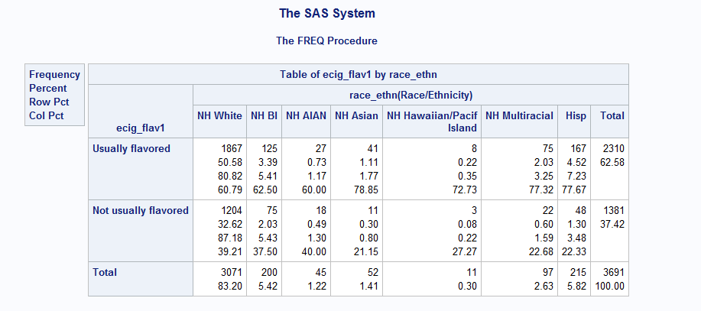
Use chi-square tests to assess significance of relationships. Conduct tests for associations between the main variable of interest and other characteristics.
Example. Associations were tested between the main measure “use of flavored e-cigarettes” and a variety of sociodemographic characteristics (age, sex, geographic location, etc.).
Create a logistic regression model. Create a model to predict the binary main measure based on other characteristics.
Example. A logistic regression model was created for both main measures. The model that predicted use of flavored e-cigarettes included age, sex, region of residence, regular cigarette smoking status, race/ethnicity, and marital status.

